Deployment Design

Online Ride Sharing

Prepared by: Musa Khan

Date: June 7th, 2018

Capital University of Science & Technology, Islamabad

Contents

I. Overview: 3

II. Target Audience: 3

III. Team members: 3

1. Hardware Specifications: 4

1.1 Hardware Environment: 4

1.2 Execution Environment: 4

2. Operating System Specifications: 5

3. Servers: 5

3.1 App Server: 5

3.2 Basic Server Diagram: 5

3.3 CPU Adjustment: 6

4. Overall Software Requirements: 6

4.1 Operating System: 6

4.2 Front End: 6

4.3 Back End: 6

4.4 Plugins: 6

**4.4.1 Google Map Plugin Code:** 6

4.5 Libraries: 7

5. Data Access Points: 7

6. Deployment Structure: 8

# Overview:

Juice Bar would be the application which would help users in ordering the favorite juices of their choices and will have the delivery of it in right place and in right time.

# Target Audience:

Admin and Customer

# Team members:

BCS153006 IKRAM ULLAH

BCS163008 HINA MAHMOOD QURESHI

BCS163029 TAHIRA NAWAZ

BCS163032 MUHAMMAD MUDASSIR

BSE163155 SAUD RAZA

BSE163014 HASHAM AKHTAR

# 1. Hardware Specifications:

* Processor: Dual-core 32-bit.
* RAM: 1Gb or higher
* Internal Memory: Internal 2GB minimum
* Other: GPS enabled

## 1.1 Hardware Environment:

The mentioned requirements are same for windows and android phone. For Windows Phone SDK will be required additionally.

## 1.2 Execution Environment:

Hardware Specifications basically deal with the Execution time. All the deployed data is executed in device with certain specifications.

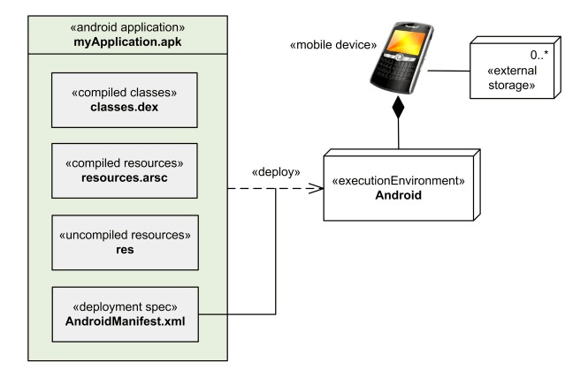

# 2. Operating System Specifications:

* Android: 4.3 or higher
* Google play must be included for safe download
* At least 1GB RAM

# 3. Servers:

* Web Server
* Location Server
* Communication Server

## 3.1 App Server:

* Lamp

## 3.2 Basic Server Diagram:

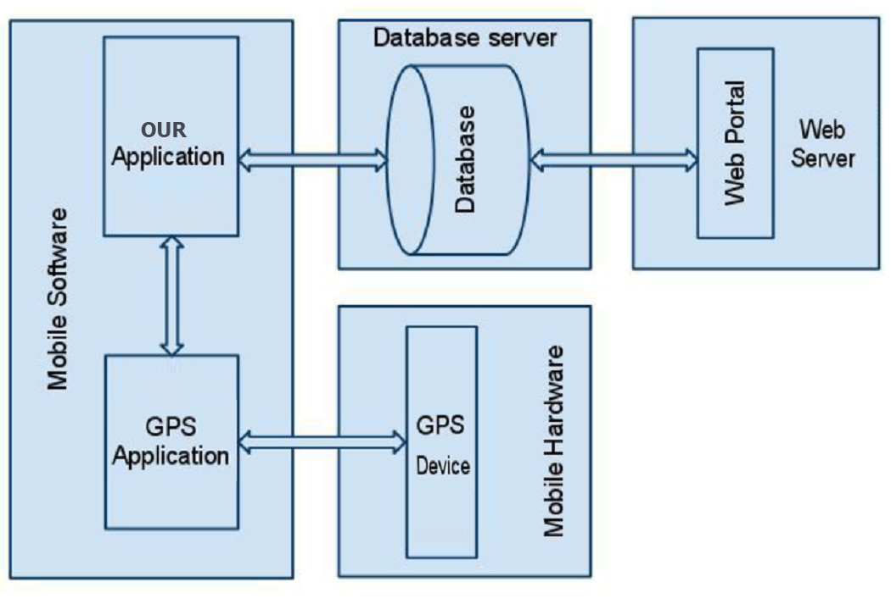

## 3.3 CPU Adjustment:

|  |  |  |
| --- | --- | --- |
| **CPU Estimate Adjustments for Supporting Components** | | |
| **Component** | **CPUs** | **Memory** |
| Web Server | 2 | 2 GB |
| Location Server | 1 | 1 GB |
| Communication Server | 2 | 2 GB |

# 4. Overall Software Requirements:

## 4.1 Operating System:

* Android 4.3 or higher

## 4.2 Front End:

* Android Studio

## 4.3 Back End:

* SQLITE Database

## 4.4 Plugins:

* Android SDK
* ADT Plugin

### **4.4.1 Google Map Plugin Code:**

boolean installedMaps = false;

// CHECK IF AN APPLICATION IS INSTALLED

PackageManager pkManager = getPackageManager();

try {

PackageInfo pkInfo = pkManager.getPackageInfo("com.google.android.apps.maps", 0); // REPLACE THIS "com.google.android.apps.maps" WITH THE ACTUAL PACAKAGE NAME

// Log.e("pkInfo", pkInfo.toString());

installedMaps = true;

} catch (NameNotFoundException e) {

e.printStackTrace();

installedMaps = false;

}

## 4.5 Libraries:

* Java Archive (JAR)
* Android Archive (AAR)

# 5. Data Access Points:

|  |  |  |
| --- | --- | --- |
| **Hardware Class** | **Relative Access Speed** | **Remedies for Performance Improvement** |
| Processor | Nanoseconds | Vertical scaling:  Add more processing power, improve processor cache  Horizontal scaling:  Add parallel processing power for load balancing |
| System memory (RAM) | Microseconds | Dedicate system memory to specific tasks  Vertical scaling:  Add additional memory  Horizontal scaling:  Create additional instances for parallel processing and load balancing |
| Disk read and write | Milliseconds | Optimize disk access with disk arrays (RAID)  Dedicate disk access to specific functions, such as read only or write only  Cache frequently accessed data in system memory |
| Network interface | Varies depending on bandwidth and access speed of nodes on the network | Increase bandwidth  Add accelerator hardware when transporting secure data  Improve performance on nodes within the network so the data is more readily available |

# 6. Deployment Structure:

Online Ride Sharing

Execution Environment

Server

Hardware

Operating System

Database

Application Server

Web Server

Student